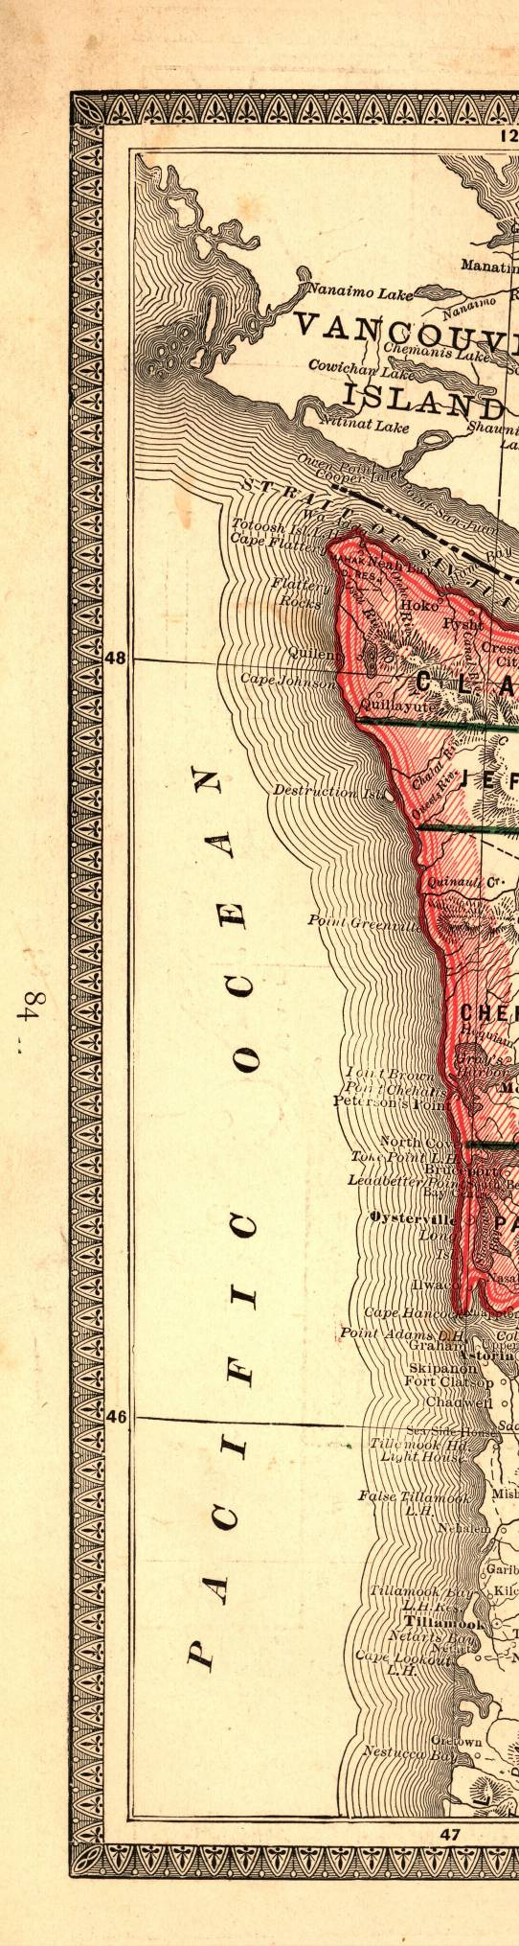
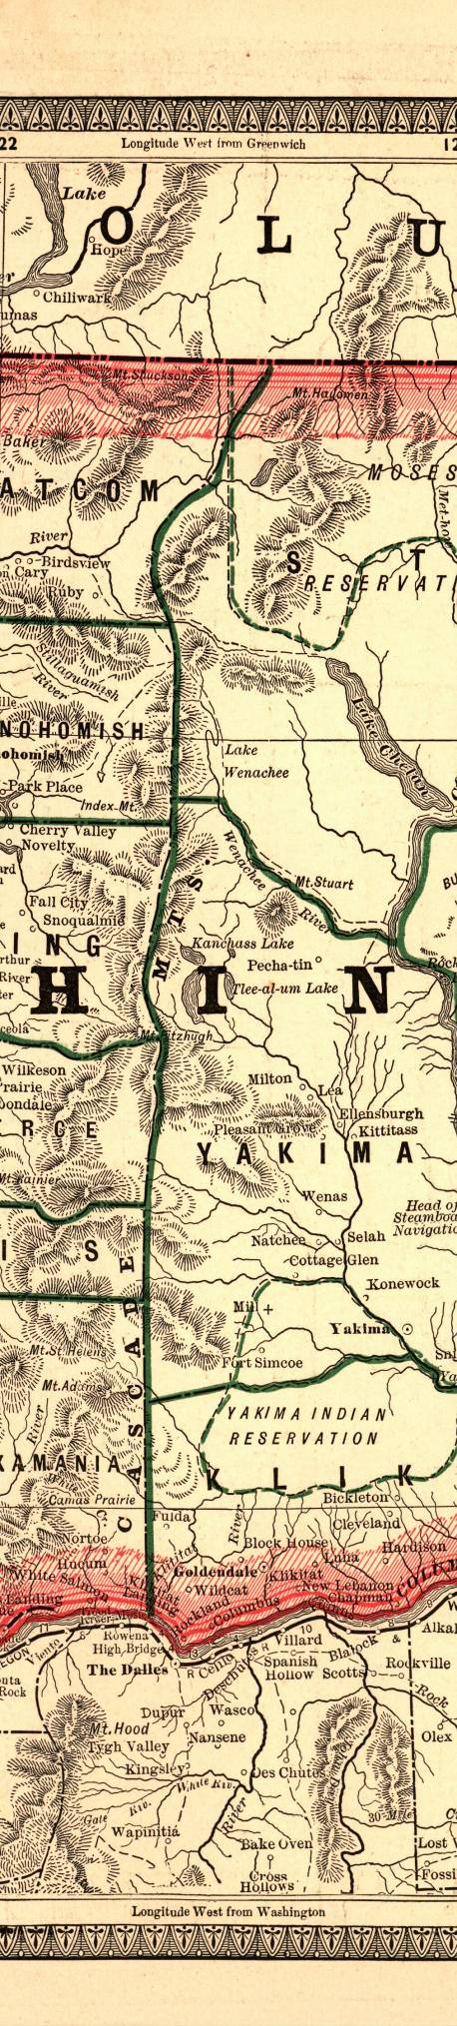
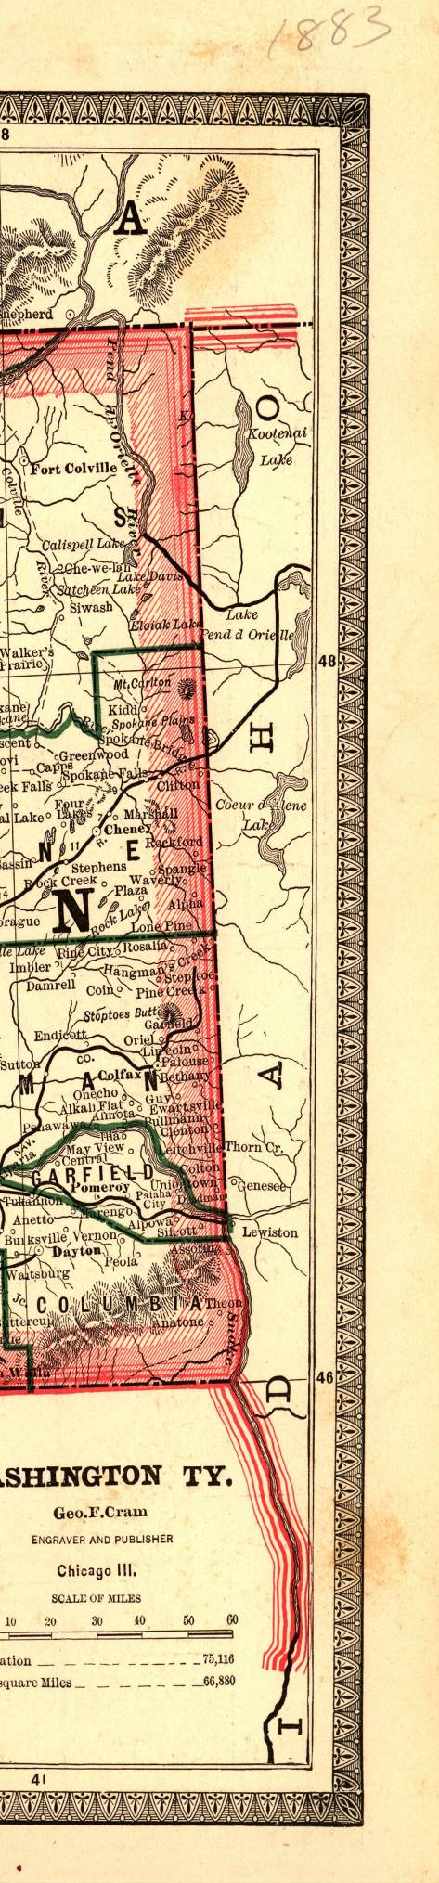
Washington State Historical Records Advisory Board

2009-2011
Digitization Program
Guidebook and Application

* * * * * * * * * *
Connecting Washington’s History

WASHINGTON STATE ARCHIVES
In partnership with the
National Historic Publications and Records Commission
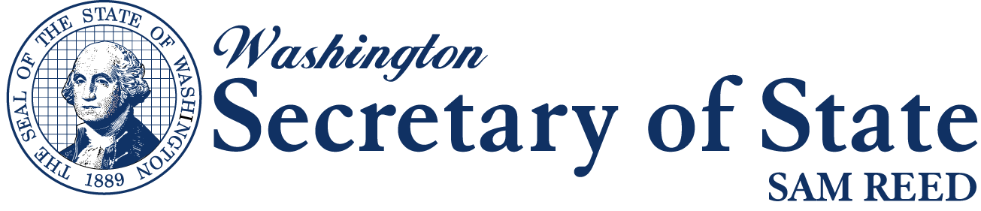

Revised Application Deadline: June 01, 2010

For more information: http://www.sos.wa.gov/archives/wshrab.aspx

Jerry Handfield Patrick Williams
State Archivist Local Records Grant Coordinator
jerry.handfield@sos.wa.gov patrick.williams@sos.wa.gov
360-586-2664 360-586-0108

TABLE OF CONTENTS
TABLE OF CONTENTS 1
1. INTRODUCTION 2
Why should you be interested in this grant? 2
1.1 Purpose 2
1.2 Focus for WSHRAB Digitization Program 2
1.3 Timetable 3
1.4 Eligible Applicants 3
1.5 Outside Scope of Digitization Program 3
1.6 Approved Grant Project Categories 4
1.7 Application Review and Award Process 4
2. PROJECT INFORMATION 5
2.1 What can I expect from an award? 5
2.2 Award Payments 5
2.3 Reports 5
2.4 Project Changes 6
3. APPLICATION INSTRUCTIONS 6

1. INTRODUCTION

Why should you be interested in this grant?

- No cost to your local society group
- Free copy of the digitized records
- Free Archival Boxes
- Improved and instant access to historical records
- Easy grant to preserve and digitize records

1.1 Purpose

Established in 1976 and funded by the National Historical Records and Publications Commission, Washington State Historical Records Advisory Board (WSHRAB) is the central advisory body for historical records planning in Washington. WSHRAB promotes practices that ensure preservation of, and access to, the state’s public and private historical records. Appointed by the Secretary of State and chaired by the State Archivist, WSHRAB acts as a coordinating body to promote cooperation and communication between records repositories within the state.

In furtherance of this mission; WSHRAB is offering, for the first time, support to eligible organizations across the state in the form of free digitization of certain categories of historical records. The goal of the WSHRAB Digitization Program seeks to increase the availability of local government records that are not in the custody of the Washington State Archives by providing institutions with assistance and digitization services worth up $5,000 to scan records thereby improving preservation and increasing the potential for worldwide access. Further information on what organizations may apply, what local government records are eligible and what services will be provided is described below.

1.2 Focus for WSHRAB Digitization Program
Improved public access to legal and historical local government records, better preservation of the records and consolidation of collections are major goals of the WSHRAB Digitization Program. Currently collections of local government agencies may be fragmented in multiple locations. In some cases researchers are unaware of the location of records, and the facilities in which they are housed have limited ability to serve the researcher and properly preserve the records.

Increased Access. The Digitization Program will increase public access to records in multiple ways. Historical records of local government agencies will be more accessible when images of the records become available worldwide through the Washington State Digital Archives and optionally, the applicant’s web site. Access will increase locally when originals or copies are available at a Washington State Archives Regional Branch and in the research room of the applicant. As associated indexing is accomplished, records imaged through the WSHRAB Digitization Program will be added to the Digital Archives. Applications that will increase access to the records by placing them on an organization’s web site will receive priority, but this is not a requirement.

Improved Preservation. Preservation of records can be improved when their direct use is lessened and their conditions of storage are upgraded. The life-span of records is increased when digital copies are made available to the public, rather than originals of the records which may be old, brittle and otherwise deteriorating. Often an organization’s facility does not provide the proper environment for records, whereas eventual transfer of records to Regional Archives Branches with cooler and more stable storage conditions can improve longevity dramatically.

Consolidation of Collections. Regional Archives Branch collections will often possess additional records of the same creating local government agency offering the potential consolidation of collections in one location. Priority will be given to projects that result in the eventual legal transfer of the records, but this is not a requirement.

Historical records of all types created by local government agencies and no longer in government custody are eligible for digitization. Priority records include: records in need of preservation, especially those from the territorial and early statehood periods of Washington; local censuses; proceedings of commissions, boards and councils; historic maps and photographs; school records; and assessor and other records useful for house history. Records for which privacy restrictions apply will not be made available online or in research rooms without removal of the restricted information and may be given lesser priority for acceptance as part of the Digitization Program.
State Archives staff will assist you in determining a sound project for your organization and can answer questions relating to your records.

1.3 Timetable
Each project will begin on the date of the award letter from WSHRAB and will run through May 31, 2011. All work on the grant project must be complete and invoiced by May 15, 2011.

October 2009 WSHRAB Digitization Program Announced
June 01, 2010 Applications deadline
June 07, 2010 Applications reviewed and recommended
July 2010 Awards announced
January 10, 2011 1st interim narrative reports due
May 15, 2011 All work on projects must be complete and invoiced
May 31, 2011 Final narrative reports due

1.4 Eligible Applicants
Historical organizations, genealogical societies, museums, academic archives and similar institutions that possess records created by local government agencies are eligible to apply through a competitive process. Individuals and agencies of local government are ineligible; as are societies, museums and libraries that are operated by a division of local, state or federal government. Based on RCW 40.14.070, the Archivist of the State of Washington will determine whether local government records in such repositories are eligible for the Digitization Program. There is no requirement for a monetary or in-kind match.

1.5 Outside Scope of Digitization Program
Organizations may not apply to receive money for equipment and personnel. The WSHRAB Digitization Program is primarily a service to provide digital images of local government records in order to; increase access, improve preservation and consolidate collections.

1.6 Approved Grant Project Categories
Approved project budget categories eligible for grant funding include:
- Scanning of hard copy records. Washington State Archives Imaging Services is the required vendor for all digitization projects. In the event that Imaging Services is unable to undertake or complete a project, recipients will be allowed to secure a different vendor.
- One cu. ft. archival boxes for transportation of records. As far as possible, all records receiving grant funds must be stored and transported in on cu. ft archival boxes. These sturdy, acid-free boxes ($2.20 ea.) are available through your Regional Branch, and costs can be included in your grant budget request. Specialized boxes will not be available for purchase through the WSHRAB Digitization Program.
- Additional services and commodities pertinent and necessary to the project, specifically hard drives or CDs for returning digital images and mileage costs for transportation of records.

1.7 Application Review and Award Process

The application review process is a competitive one, with a limited amount of money available for distribution. Projects that meet the criteria of the WSHRAB Digitization Program that are well conceived, fully described, and adequately supported in a complete application form, will receive the most favorable review. State Archives Branch staff and the Digitization Program Coordinator are available to provide assistance and guidance in completing the application prior to the application deadline. Additional merit will be given towards applicants who plan to transfer the original documents to the Regional Archives.

Applications are reviewed for eligibility, completeness, conformity to application requirements, soundness of budget and relevance to the purpose of the Digitization Program. A committee designated by WSHRAB evaluates applications and determines award recommendations (full, partial, or denial of funding). All applicants are notified by mail.

In evaluating applications, the review committee will consider the importance and historical value of the records and the overall soundness of the proposed project. They are guided by the following criteria in making recommendations on applications:

- Urgency of Problem: Special consideration is given to organizations with critical preservation problems with the records and/or with their storage facility.
- Significance and Age of Records: The committee will give special consideration to those proposals addressing digitization of older local government records, especially those from the territorial and early statehood periods of Washington. Regardless of age, other records of value include local censuses; proceedings of commissions, boards and councils; official files of elected officials; historic maps and photographs; school records; and assessor and other records useful for house and building history.
- Increased Accessibility: Special consideration will be given to those proposals that increase the public’s access to the records. Projects that make records accessible on an organization’s web site will receive priority. Similarly, applications for records with existing indexes or finding aids will be given priority as will those that involve records that may be easily indexed for the Washington State Digital Archives, especially if an organization is willing to provide indexing for the records either through the efforts of the staff and volunteers or through existing indexes. The availability of finding aids or indexes for the records may strengthen an application.
- Consolidation of Collections: Additional consideration will be given to projects that result in the transfer of the original local government records to the Washington State Archives.

2. PROJECT INFORMATION

2.1 What can I expect from an award?

- Your records will be picked up by Washington State Archives where they will be digitized and indexed (named) according to predetermined criteria. Each record will be indexed and imaged as a separate document. You will receive a hard drive or CD with TIFF images of the records which may be placed on an external or internal web site or network. The original records will be picked up from your organization by State Archives personnel and returned to you or to the regional archives branch as arranged.
- Copies of the images will be transferred to the Washington State Digital Archives and the local Regional Archives Branch for preservation. The State Archives receives full rights to make the images available to researchers. The images will become accessible in the Branch reading room and worldwide on the Digital Archives after full indexing is accomplished.

2.2 Award Payments

No funds will be disbursed to the Grantee. The payment of credit for services is as described:
- An invoice will be created by the Agency’s Financial Services upon delivery of Archival Storage boxes.
- The invoice will be paid by the Agency through a transfer of funds upon delivery of Archival Storage boxes.
- An invoice will be created by the Agency’s Imaging Services upon delivery of the completed project.
- The invoice will be paid by the Agency through a transfer of funds upon approval by the Grantee of services provided.
- The Agency will send a copy of the paid invoices for reference to the Grantee.
Costs incurred prior to the effective date of the Grant Agreement shall be disallowed under the Grant. Should the Grantee incur costs prior to the effective date of the Grant Agreement, it does so at its own risk.

2.3 Reports

The WSHRAB Digitization Program rules stipulate that both narrative and financial components be reported during the project period. Online forms will be available at http://www.sos.wa.gov/archives/wshrab.aspx. One narrative report is required. The report covers the period from the project’s commencement through December 30, 2010, and is due on January 10, 2011. In addition, a final report is due upon completion of project, but no later than May 31, 2011. Copies of invoices for grant project expenditures must be attached.

2.4 Project Changes

The WSHRAB Coordinator (State Archivist of Washington) must receive a written request prior to any revisions to a project’s budget. The written request must include the reason for the revision, the total dollar amount of funds to be reallocated, and identification of which budget categories and/or budget line items are to be reduced or increased, and by what amount. Program change requests, such as added or deleted record series, also require a prior written request.

3. APPLICATION INSTRUCTIONS

Submit your original signed application, stapled in the upper left-hand corner. Do not use tabs, dividers, binders or folders. Applications MUST be postmarked no later than June 01, 2010. No faxed or e-mailed applications will be accepted. Please use the following address:

WSHRAB Digitization Program
Washington State Archives
1129 Washington St SE
Olympia, WA 98504
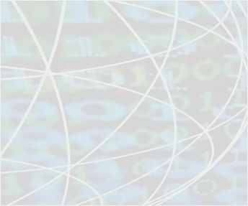
2009-11
WSHRAB DIGITIZATION PROGRAM
Call or e-mail the Regional branch Archives to get help with your Grant Application

Northwest Counties: 360-650-7930 state.archives@wwu.edu

Clallam, Island, Jefferson, San Juan, Skagit, Snohomish, Whatcom Counties

Southwest Counties: 360-753-1684 swresearch@sos.wa.gov

Clark, Cowlitz, Grays Harbor, Lewis, Mason, Pacific, Skamania, Thurston, Wahkiakum Counties

Eastern Counties: 509-235-7508 era@sos.wa.gov

Adams, Asotin, Columbia, Ferry, Garfield, Lincoln, Pend Oreille, Spokane, Stevens, Walla Walla and Whitman Counties

Central Counties: 509-963-2136 archives@cwu.edu

Benton, Chelan, Douglas, Franklin, Grant, Kittitas, Klickitat, Okanogan, Yakima Counties

Puget Sound Counties: 425-564-3940 archives@bellevuecollege.edu

King, Kitsap, Pierce Counties

Questions regarding the Digitization Program, your project, or your application may also be directed to:

WSHRAB Digitization Program Coordinator:
Patrick Williams 360-586-0108 patrick.williams@sos.wa.gov

Application Deadline: June 1st, 2010
WSHRAB DIGITIZATION PROGRAM
Washington State Archives
1129 Washington St SE
Olympia, WA 98504
http://www.sos.wa.gov/archives/wshrab.aspx

