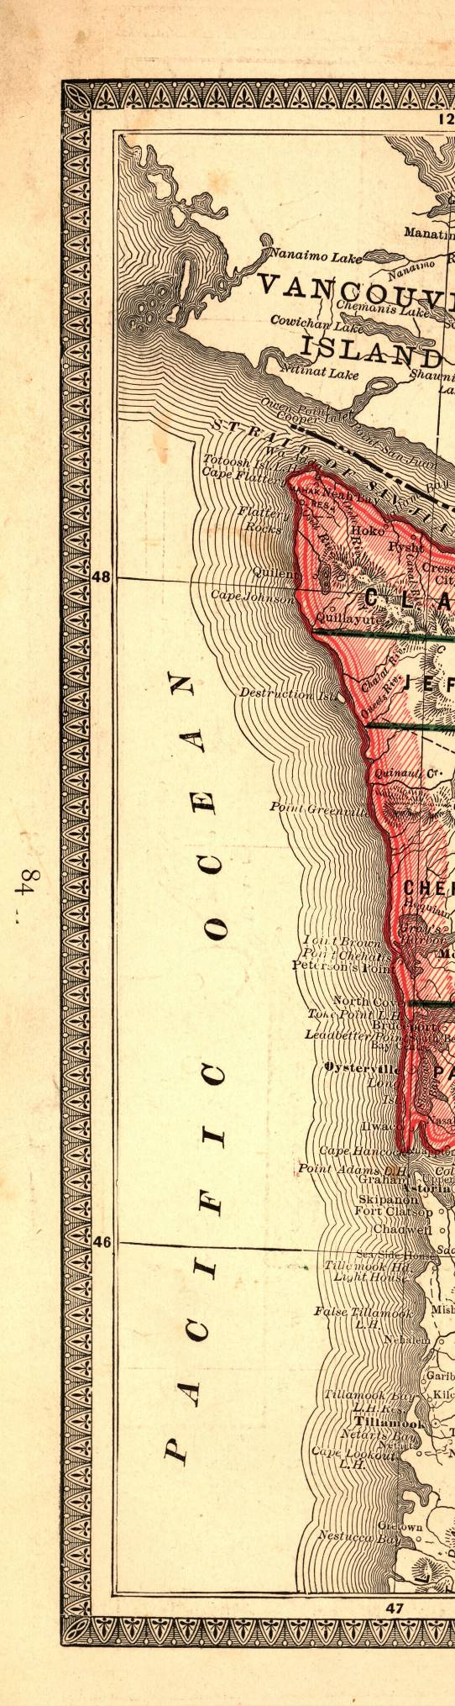
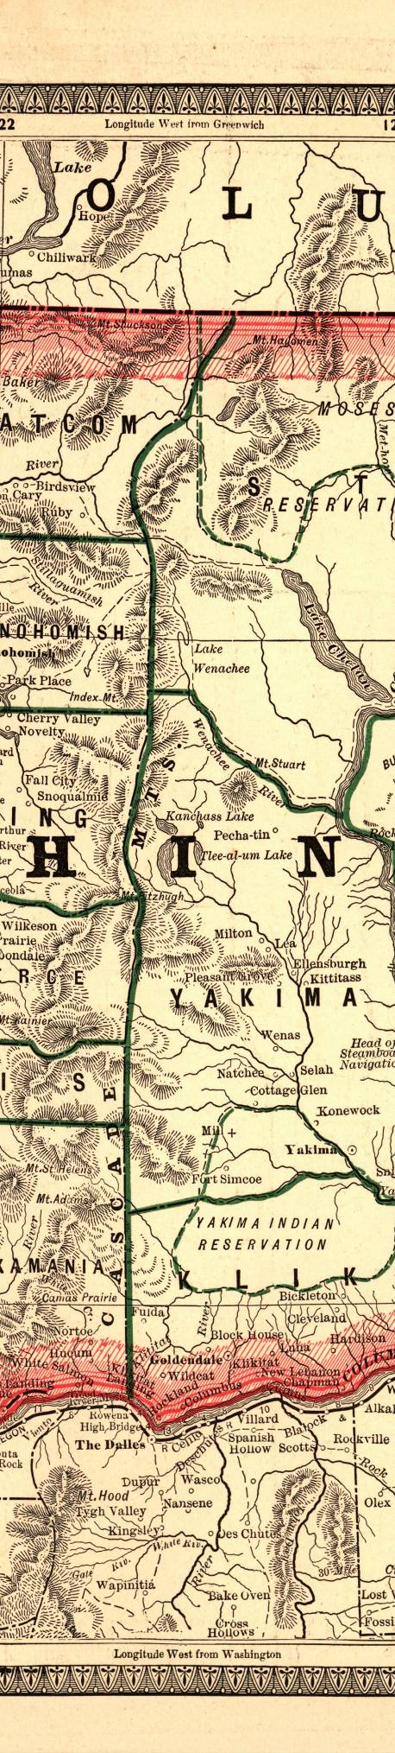
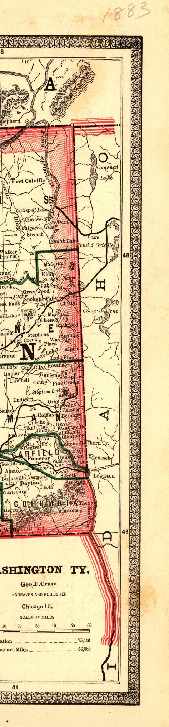
Washington State Historical Records Advisory Board

2011
Digitization Program
Guidebook and Application

* * * * * * * * * *
Connecting Washington’s History

WASHINGTON STATE ARCHIVES
In partnership with the
National Historical Publications and Records Commission
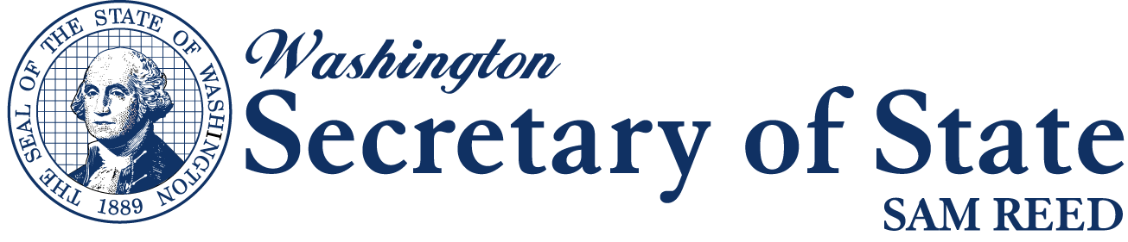

Final Application Deadline: May 16, 2011

For more information: http://www.sos.wa.gov/archives/wshrab.aspx

Jerry Handfield Patrick Williams
State Archivist Local Records Grant Coordinator
jerry.handfield@sos.wa.gov patrick.williams@sos.wa.gov
360-586-2664 360-586-0108

TABLE OF CONTENTS
TABLE OF CONTENTS 1
WSHRAB DIGITIZATION PROGRAM GUIDEBOOK 2
1. INTRODUCTION 3
1.1 Purpose 3
1.2 Focus for WSHRAB Digitization Program 3
1.3 Timetable 4
1.4 Eligible Applicants 4
1.5 Outside Scope of Digitization Program 4
1.6 Approved Grant Project Categories 4
1.7 Application Review and Award Process 5
2. PROJECT INFORMATION 6
2.1 What can I expect from an award? 6
2.2 Staff Assistance 6
2.3 Award Payments 6
2.4 Reports 6
2.5 Project Changes 7
3. APPLICATION PREPARATION TIPS 7
3.1 Step One – Getting Oriented 7
3.2 Step Two – Getting Started 7
3.3 Step Three – Putting It All Together 7
4. APPLICATION INSTRUCTIONS 8
4.1 WSHRAB Digitization Program Application 8
Section 1 8
Section 2 9
WSHRAB DIGITIZATION GRANT 2011 Application 10
WSHRAB DIGITIZATION GRANT 2011 Application 11

WSHRAB DIGITIZATION PROGRAM GUIDEBOOK
The Washington State Historical Records Advisory Board (WSHRAB) Digitization Program; administered by the Washington State Archives of the Office of the Secretary of State, provides digitization services to eligible institutions that possess historically valuable local government records from Washington. This program is a significant effort in the overall mission of the State Archives Local Records Grants Program to enhance the quality of archival preservation and public access to records of enduring value.

This Guidebook is designed for institutions that wish to apply for up to $5,000 in digitization services and contains information and application forms for the program.

Applicants must consult with Washington State Regional Branch Archives staff to ensure a strong and well-designed project proposal.
Call or e-mail the Regional Branch to discuss what you would like to accomplish with a Digitization Program award and to get help developing your project proposal.

Northwest Counties: 360-650-7930 NWBranchArchives@sos.wa.gov

Clallam, Island, Jefferson, San Juan, Skagit, Snohomish, Whatcom Counties

Southwest Counties: 360-753-1684 SWBranchArchives@sos.wa.gov

Clark, Cowlitz, Grays Harbor, Lewis, Mason, Pacific, Skamania, Thurston, Wahkiakum Counties

Eastern Counties: 509-235-7508 EABranchArchives@sos.wa.gov

Adams, Asotin, Columbia, Ferry, Garfield, Lincoln, Pend Oreille, Spokane, Stevens, Walla Walla and Whitman Counties

Central Counties: 509-963-2136 CEBranchArchives@sos.wa.gov

Benton, Chelan, Douglas, Franklin, Grant, Kittitas, Klickitat, Okanogan, Yakima Counties

Puget Sound Counties: 425-564-3940 PSBranchArchives@sos.wa.gov

King, Kitsap, Pierce Counties

Questions regarding the Digitization Program, your project, or your application may also be directed to:

WSHRAB Digitization Program Coordinator:
Patrick Williams 360-586-0108 patrick.williams@sos.wa.gov

Applications MUST BE POSTMARKED no later than May 16, 2011
Washington State Archives
1129 Washington St. SE
Olympia, WA 98504

1. INTRODUCTION

1.1 Purpose

Established in 1976 and funded by the National Historical Records and Publications Commission, WSHRAB is the central advisory body for historical records planning in Washington. WSHRAB promotes practices that ensure preservation of, and access to, the state’s public and private historical records. Appointed by the Secretary of State and chaired by the State Archivist, WSHRAB acts as a coordinating body to promote cooperation and communication between records repositories within the state.

In furtherance of this mission; WSHRAB is offering, for the first time, support to eligible organizations across the state in the form of free digitization of certain categories of historical records. The goal of the WSHRAB Digitization Program seeks to increase the availability of local government records that are not in the custody of the Washington State Archives by providing institutions with assistance and digitization services worth up $5,000 to scan records thereby improving preservation and increasing the potential for worldwide access. Further information on what organizations may apply, what local government records are eligible and what services will be provided is described below.

1.2 Focus for WSHRAB Digitization Program
Greater access to historical local government records, better preservation of the records and consolidation of collections are major goals of the WSHRAB Digitization Program. Currently collections of local government agencies may be fragmented in multiple locations. In some cases researchers are unaware of the location of records, and the facilities in which they are housed have limited ability to serve the researcher and properly preserve the records.

Increased Access. The Digitization Program will increase public access to records in multiple ways. Historical records of local government agencies will be more accessible when images of the records become available worldwide through the Washington State Digital Archives and potentially the applicant’s web site. Access will increase locally when originals or copies are available at a Washington State Archives Regional Branch and in the research room of the applicant. As associated indexing is accomplished, records imaged through the WSHRAB Digitization Program will be added to the Digital Archives. Applications that will increase access to the records by placing them on an organization’s web site will receive priority, but this is not a requirement.

Improved Preservation. Preservation of records can be improved when their direct use is lessened and their conditions of storage are upgraded. The life-span of records is increased when digital copies are made available to the public, rather than originals of the records which may be old, brittle and otherwise deteriorating. Often an organization’s facility does not provide the proper environment for records, whereas eventual transfer of records to Regional Archives Branches can improve storage conditions dramatically.

Consolidation of Collections. Regional Archives Branch collections will often possess additional records of the same creating local government agency offering the potential consolidation of collections in one location. Priority will be given to projects that result in the eventual legal transfer of the records, but this is not a requirement.

Historical records of all types created by local government agencies and no longer in government custody are eligible for digitization. Priority records include: records in need of preservation, especially those from the territorial and early statehood periods of Washington; local censuses; proceedings of commissions, boards and councils; historic maps and photographs; school records; and assessor and other records useful for house history. Records for which privacy restrictions apply will not be made available online or in research rooms without removal of the restricted information and may be given lesser priority for acceptance as part of the Digitization Program.
State Archives staff will assist you in determining a sound project for your organization and can answer questions relating to your records.

1.3 Timetable
Each project will begin on the date of the award letter from WSHRAB and will run through December 31, 2011. All work on the grant project must be complete and invoiced by December 31, 2011.

March 15, 2011 WSHRAB 2011 Digitization Program announced
May 16, 2011 Application deadline
May, 2011 WSHRAB Digitization Program subcommittee reviews and recommends
June 2011 Awards announced
June - November 2011 Disbursement of funds upon execution of contract
December 31, 2011 All work on projects must be complete and invoiced
January 31, 2012 Final narrative report due and all unspent monies repaid

1.4 Eligible Applicants
Historical organizations, genealogical societies, museums, academic archives and similar institutions that possess records created by local government agencies are eligible to apply through a competitive process. Individuals and agencies of local government are ineligible; as are societies, museums and libraries that are operated by a division of local, state or federal government. Based on RCW 40.14.070, the Archivist of the State of Washington will determine whether local government records in such repositories are eligible for the Digitization Program. There is no requirement for a monetary or in-kind match.

1.5 Outside Scope of Digitization Program
Organizations may not apply to receive money for equipment and personnel. The WSHRAB Digitization Program is primarily a service to provide digital images of local government records in order to; increase access, improve preservation and consolidate collections.

1.6 Approved Grant Project Categories
Approved project budget categories eligible for grant funding include:
- Scanning of hard copy records. Washington State Archives Imaging Services is the required vendor for all digitization projects. In the event that Imaging Services is unable to undertake or complete a project, recipients will be allowed to secure a different vendor.
- One cu. ft. archival boxes for transportation of records. As far as possible, all records receiving grant funds must be stored and transported in on cu. ft archival boxes. These sturdy, acid-free boxes ($2.20 ea.) are available through your Regional Branch, and costs can be included in your grant budget request. Specialized boxes will not be purchased through the WSHRAB Digitization Program.
- Additional services and commodities pertinent and necessary to the project, specifically hard drives or CDs for returning digital images and mileage costs for transportation of records.

1.7 Application Review and Award Process

The application review process is a competitive one, with a limited amount of money available for distribution. Projects that meet the criteria of the WSHRAB Digitization Program that are well conceived, fully described, and adequately supported in a complete application form, will receive the most favorable review. State Archives Branch staff and the Digitization Program Coordinator are available to provide assistance and guidance in completing the application prior to the application deadline. Additional merit will be given towards applicants who plan to transfer the original documents to the Regional Archives.

Applications are reviewed for eligibility, completeness, conformity to application requirements, soundness of budget and relevance to the purpose of the Digitization Program. A committee designated by the Washington State Historical Records Advisory Board (WSHRAB) evaluates applications and determines award recommendations (full, partial, or denial of funding). All applicants are notified by mail.

In evaluating applications, the review committee will consider the importance and historical value of the records and the overall soundness of the proposed project. They are guided by the following criteria in making recommendations on applications:
- Urgency of Problem: Special consideration is given to organizations with critical preservation problems with the records and/or with their storage facility.
- Significance and Age of Records: The committee will give special consideration to those proposals addressing digitization of older local government records, especially those from the territorial and early statehood periods of Washington. Regardless of age, other records of value include local censuses; proceedings of commissions, boards and councils; official files of elected officials; historic maps and photographs; school records; and assessor and other records useful for house and building history.
- Increased Accessibility: Special consideration will be given to those proposals that increase the public’s access to the records. Projects that make records accessible on an organization’s web site will receive priority. Similarly, applications for records with existing indexes or finding aids will be given priority as will those that involve records that may be easily indexed for the Washington State Digital Archives, especially if an organization is willing to provide indexing for the records either through the efforts of the staff and volunteers or through existing indexes. The availability of finding aids or indexes for the records may strengthen an application.
- Consolidation of Collections: Additional consideration will be given to projects that result in the transfer of the original local government records to the Washington State Archives.

2. PROJECT INFORMATION

2.1 What can I expect from an award?

- Your records will be received by Imaging Services where they will be digitized and indexed (named) according to predetermined criteria. Each record will be indexed and imaged as a separate document. You will receive a hard drive or CD with TIFF images of the records which may be placed on an external or internal web site or network. The original records will be picked up from your organization by State Archives personnel and returned to you or to the regional archives branch as arranged.
- Copies of the images will be transferred to the Washington State Digital Archives and the local Regional Archives Branch for preservation. The State Archives receives full rights to make the images available to researchers. The images will become accessible in the Branch reading room and worldwide on the Digital Archives after full indexing is accomplished.

2.2 Staff Assistance

Retain this Guidebook for your reference and use after award of Digitization Program funds. Many questions that will arise as you implement your project are covered in this publication. Additional pertinent information, materials and forms will be sent to the project contact after funds are awarded.
Washington State Archives staff is available to guide and assist you in applying for and in successfully completing your project. Contact information is on the first page of this Guidebook.

2.3 Award Payments

No funds will be disbursed to the Grantee. The payment of credit for services is as described:
- An invoice will be created by the Agency’s Financial Services upon delivery of Archival Storage boxes.
- The invoice will be paid by the Agency through a transfer of funds upon delivery of Archival Storage boxes.
- An invoice will be created by the Agency’s Imaging Services upon delivery of the completed project.
- The invoice will be paid by the Agency through a transfer of funds upon approval by the Grantee of services provided.
- The Agency will send a copy of the paid invoices for reference to the Grantee.
Costs incurred prior to the effective date of the Grant Agreement shall be disallowed under the Grant. Should the Grantee incur costs prior to the effective date of the Grant Agreement, it does so at its own risk.

2.4 Reports

The WSHRAB Digitization Program rules stipulate that both narrative and financial components be reported during the project period. Online forms will be available at http://www.sos.wa.gov/archives/wshrab.aspx. A final report is due upon completion of project, but no later than January 31, 2012. Copies of invoices for grant project expenditures must be attached. A check for unexpended award monies, and/or unexpended interest earned on those monies, must be returned to the Washington State Archives within 60 days of the completion of the project. Secretary of State Financial Services will contact the grantee to initiate this payment.

2.5 Project Changes

The WSHRAB Coordinator (State Archivist of Washington) must receive a written request prior to any revisions to a project’s budget. The written request must include the reason for the revision, the total dollar amount of funds to be reallocated, and identification of which budget categories and/or budget line items are to be reduced or increased, and by what amount. Program change requests, such as added or deleted record series, also require a prior written request.

3. APPLICATION PREPARATION TIPS

3.1 Step One – Getting Oriented

- READ this Guidebook and Application to become familiar with the program.
- Determine if your organization is eligible for this program.
- Understand what your responsibilities will be if you are awarded funding.
- Objectively evaluate your resources: Do you have a realistic estimate of the funds, staffing and time needed to undertake and complete your project within the time frame?

3.2 Step Two – Getting Started

- Call or e-mail your Regional Branch to discuss what you would like to accomplish with the WSHRAB Digitization Program. This step will help your organization to develop a strong and well-designed project proposal that reflects best practices.
- KEEP this Guidebook! You will want to refer to specific sections as you develop your proposal, and it will be a ready source of information to effectively administer an award.
- Allow sufficient time to develop a successful proposal; do not procrastinate.
- Prepare a draft and, in coordination with the Regional Branch, edit and revise to achieve the best proposal possible.

3.3 Step Three – Putting It All Together

- Fill out the Application in digital format and print out the original for the necessary signatures.
- Be sure to respond to all questions and sections to complete the application.
- Have someone review your draft for clarity, typos and spelling errors.
- Make sure you have the two required signatures of organization officials.
- Submit only the required form; your proposal will be judged on content, not weight.

4. APPLICATION INSTRUCTIONS

Submit your original signed application, stapled in the upper left-hand corner. Do not use tabs, dividers, binders or folders. Applications MUST be postmarked no later than May 16, 2011. No faxed or e-mailed applications will be accepted. Please use the following address:

WSHRAB Digitization Program
Washington State Archives
1129 Washington St SE
Olympia, WA 98504

4.1 WSHRAB Digitization Program Application

Section 1
Primary Project Contact
- This is the individual responsible for implementing the project on a day-to-day basis. State Archives contact will be with this individual during the grant project.
Authorizing Official
- The signatory individual must be the authorized official with the authority to enter into binding contracts and encumber funds for the applicant organization. This official will also be the signatory agent for the Agreement, which establishes a contractual relationship between Secretary of State, Washington State Archives and the awarded organization.
Application Prepared by
- This entry identifies the individual responsible for gathering the application information and completing the forms. State Archives will contact this person should specific information pertaining to the proposed project be required.
Legislative District
- This information is used for statistical purposes and to notify elected officials when grants are awarded. If you are unsure of the district, please call your local election authority.
Federal Employer Identification Number (FEIN)
- This number is necessary to set up your grant payment account.
Signature of official
- Signature of the Authorizing Official establishes official approval of the submitted project proposal and budget.

Section 2
List all records you are proposing to digitize with awarded funds. This is best done working with your Regional Archives Branch.

Creator
- Provide the local government agency that created the records. List the office, department, program or division that created the records if known as well.

Record Types
- Titles of each separate kind of records (records series). See the Local Government General Retention Schedule (http://www.secstate.wa.gov/archives/gs.aspx#local) or the Washington State Archives catalog (http://www.secstate.wa.gov/archives/search.aspx) for records series names.

Inclusive Dates
- The years included in the records series.

Approximate Total Pages
- Indicate a rough estimate of total pages; exact numbers are not necessary. A 1 cu. ft State Archives box holds approximately 2,500 pages lengthwise or 2,000 widthwise. Measure records by the foot, if necessary.

WSHRAB DIGITIZATION GRANT 2011 Application
Section 1
This will be used to build contact information for the applicant

Applying Organization

Organization Head (First, Last) |  | Position Title/Division | Phone Number
Email – Organization Head |  | County | Fax number
Name of Primary Project Contact (First, Last) |  | Position Title/Division | Secondary Phone Number
Email – Primary Project Contact |  | Legislative District | Website (if applicable)
Organization Address (Street, City, State, ZipCode) |  | Mailing Address - if different (Street, City, State, Zip Code)
Notes or Additional Information:

Federal Employer Identification Number (FEIN):

Signature Showing Certification Of Authority To Proceed With The Project
/  Signature of Organization Head Date | /  Signature of Project Contact Date
To Be Completed By Washington State Archives Staff Only
Application Complete & Accepted | Grant Awarded or Denied Date
Name Date | Notification Mailed Date

WSHRAB DIGITIZATION GRANT 2011 Application
Section 2
This information will be used to help Archives Staff prioritize the preservation of your records
- Please define the collection for each Creating Local Government and record type.

Creator | Record Type | Date Range (Years) | Number of Pages

- Are there any gaps in the date ranges specified above?

Yes Year through Year

No

- Will you be transferring your original records to the Washington State Archives?

Yes No

- What is the overall condition of these records?

Poor Fair Good Excellent

- Are there any additional finding aids or indexes associated with these records?
Yes No

5. Have you discussed this grant application with your Regional Archives Contact?
Yes No

6. How many Archival Boxes will you be requesting?

boxes

2011
WSHRAB DIGITIZATION PROGRAM
Call or e-mail the Regional branch Archives to get help with your Grant Application

Northwest Counties: 360-650-7930 NWBranchArchives@sos.wa.gov

Clallam, Island, Jefferson, San Juan, Skagit, Snohomish, Whatcom Counties

Southwest Counties: 360-753-1684 SWBranchArchives@sos.wa.gov

Clark, Cowlitz, Grays Harbor, Lewis, Mason, Pacific, Skamania, Thurston, Wahkiakum Counties

Eastern Counties: 509-235-7508 EABranchArchives@sos.wa.gov

Adams, Asotin, Columbia, Ferry, Garfield, Lincoln, Pend Oreille, Spokane, Stevens, Walla Walla and Whitman Counties

Central Counties: 509-963-2136 CEBranchArchives@sos.wa.gov

Benton, Chelan, Douglas, Franklin, Grant, Kittitas, Klickitat, Okanogan, Yakima Counties

Puget Sound Counties: 425-564-3940 PSBranchArchives@sos.wa.gov

King, Kitsap, Pierce Counties

Questions regarding the Digitization Program, your project, or your application may also be directed to:

WSHRAB Digitization Program Coordinator:
Patrick Williams 360-586-0108 patrick.williams@sos.wa.gov

Application Deadline: May 16, 2011
WSHRAB DIGITIZATION PROGRAM
Washington State Archives
1129 Washington St SE
Olympia, WA 98504
http://www.sos.wa.gov/archives/wshrab.aspx

